Arrivals and End of Day Map and Procedures
Morning Arrivals
EC- Early Childhood health checks will take place at the playground entrance from 8:40-9:00am. Everyone 10 and older should be masked and observe social distance while waiting for entrance. Parents should plan to enter the building with their children and walk their Early Childhood students to their classroom. Older children can proceed to the table in the atrium for their nametags.
OC- Older Children health checks will take place at the Entrance D from 8:40-9:00am. Everyone 10 and older should be masked and observe social distance while waiting for entrance. Children should be accompanied in the parking lot at all times. Parents are not required to enter the building with their older students, but may if they wish. Anyone 10 and older should wear a mask as they enter the building and walk to 1st period or head to Mom’s Rest Stop (room 612.)
All arrivals after 9:30am will be checked in at Entrance J.

End Of Day
Afternoon pickup will be conducted “curbside”. Please create a paper or poster sign for your car that clearly states your child(ren)’s name and Atrium #.
Parents with children in both areas should pick up EC first, and then proceed to the OC line. A separate sign for each area is recommended.
If someone else will be picking up your children, please notify Dawn Pruyn ahead of time. (225-324-7758)
Extended Class Pickup (CYT and Our Gang) will be at 1:00pm at Entrance D (OC Pickup on map)
Entrance and exit will follow the map below.
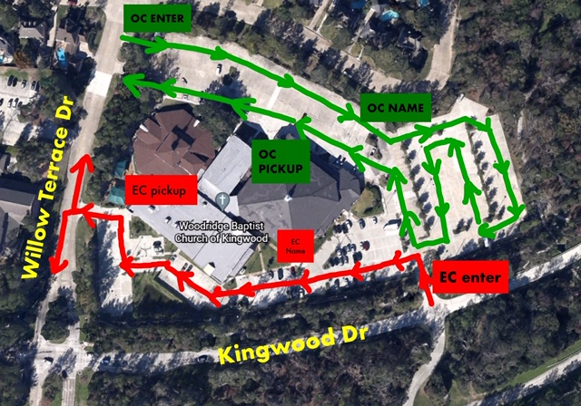

If you have to pick up your children early for any reason, please text Dawn Pruyn at 225-324-7758 and let her know.

